PROJECT DESIGN PHASE-II

DATA FLOW DIAGRAM & USER STORIES

|  |  |
| --- | --- |
| **Date** | 13 October 2022 |
| **Team ID** | PNT2022TMID02087 |
| **Project Name** | Project – AI BASED DISCOURSE FOR BANKING INDUSTRY |
| **Maximum Marks** | 4 Marks |

# Data Flow Diagrams:

The classic visual representation of how information moves through a system is a data flow diagram (DFD). A tidy and understandable DFD can graphically represent the appropriate quantity of the system demand. It demonstrates how information enters and exits the system, what modifies the data, and where information is kept.

**Simplified:**

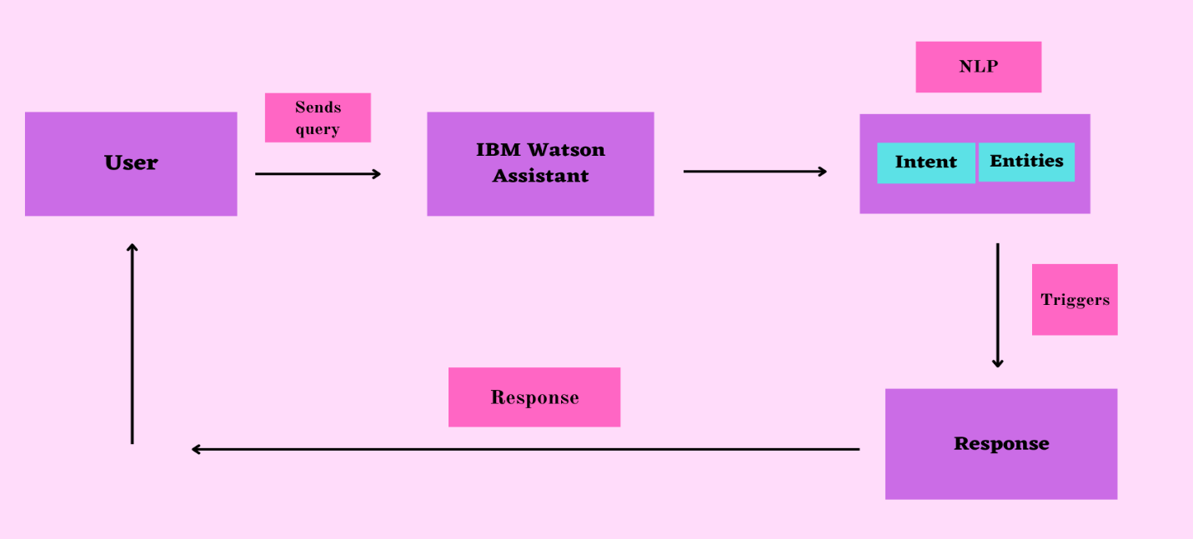

**DFD – Industry standard**

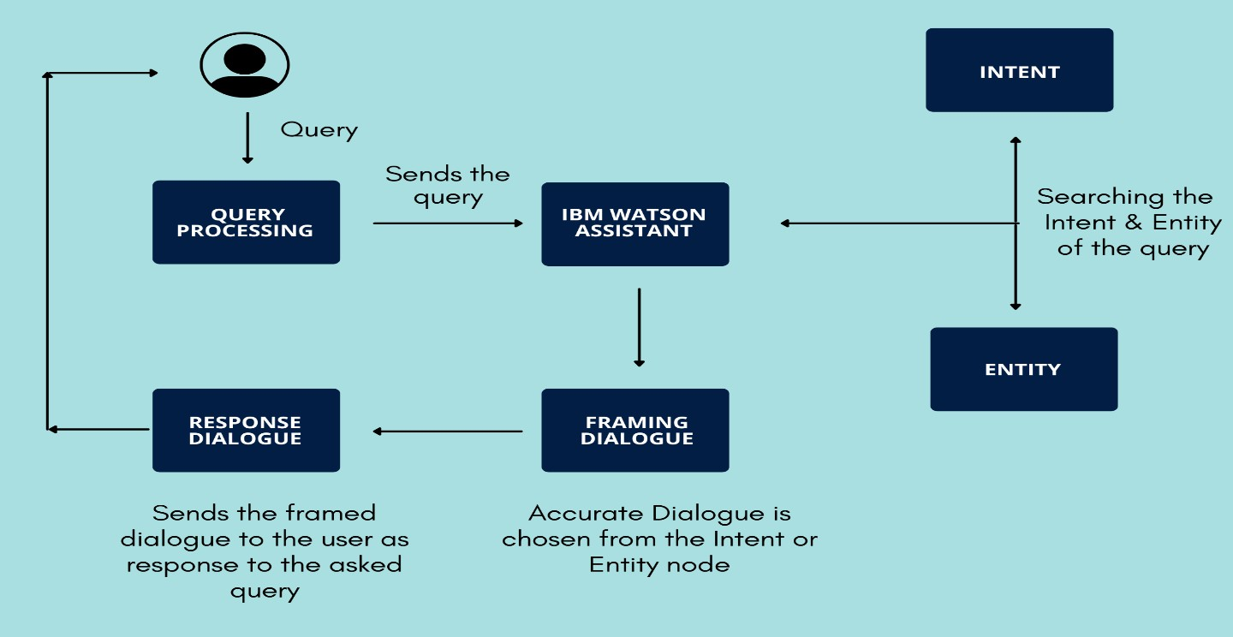

# User Stories:

|  |  |  |  |  |  |  |
| --- | --- | --- | --- | --- | --- | --- |
| **User type** | **Functional Requireme nt (Epic)** | **User story**  **Numb er** | **User Story / Task** | **Acceptance Criteria** | **Priority** | **Release** |
| Customer (Web User) | Introduction Greeting | USN-1 | I will begin by presenting myself to the bot as a user, and the bot will then introduce itself. (Initialization of the dialogue) | Introduction phase | High | Sprint 1 |
|  | Displaying Query list | USN-2 | I can see the Bot's list of displayed queries as a user. I can ask my query manually if it's not included in the list. | Now that the bot is aware of what people desire, they can input an answer that is not on the list.  needed. | High | Sprint 1 |

|  |  |  |  |  |  |  |
| --- | --- | --- | --- | --- | --- | --- |
|  |  |  |  |  |  |  |
|  | Choosing the query | USN-3 | I have the choice of selecting a question from the bot's list of options or entering my own. | Selecting the query | High | Sprint 1 |
|  | Loan query | USN-4 | You can ask and get answers to all of your loan-related questions here, including ones on the list of available loan programmes, loans for businesses, loans for education, and loan levels for each programme.  I can ask questions about net banking and receive answers. | I will get solution for my queries related to loan | Medium | Sprint 2 |
|  | Net Banking query | USN-5 | I can ask questions about net banking and receive answers. | I won't have to read through the FAQ section to find answers to my NetBanking-related questions. | Medium | Sprint 2 |
|  | Bank Account Creation | USN-6 | I can open a bank account as a user by following the instructions the bot provides.  The bot will provide the detailed instructions.  steps for opening a bank account | I can create a Bank account | Medium | Sprint 3 |

|  |  |  |  |  |  |  |
| --- | --- | --- | --- | --- | --- | --- |
|  | End Greeting | USN-7 | As a user, I will be happy with the solution, and the Bot will thank me at the conclusion, giving me the impression that I am speaking with a real person. | I can end the conversation with a sweet greeting, feeling that I have conversed with the real  Human. | Medium | Sprint 3 |
|  | Response | USN-8 | I want the response as soon as possible as a user so that I don't have to slog through FAQs or browse the full website on my own. | I will be able to get quick response without wandering through FAQ | Medium | Sprint 2 |
|  | User Friendly user experience | USN-9 | As a user, I want to have the impression that I'm speaking to a real person, so I need to have a positive user experience. | I'll experience talking to a genuine person. | Medium | Sprint 3 |
| Bank Staff | Solving queries which can’t be solved by Chatbot | USN- 10 | If the query can't be answered by the bot, the bot will direct me (the user) to the bank staff. As a user, I will ask my questions directly to the bank personnel. | I don't have to rely solely on the bot; whenever necessary, it will direct the user to the bank employees. | Medium | Sprint 3 |